In the Quick Find lecture the prof shows a connection between number by matching their id in the id array. Is this number fairly arbitrary, or are there some rules I'm missing?  
  
For example, in connecting numbers 4 to 3, both ids are changed to 3:    
  
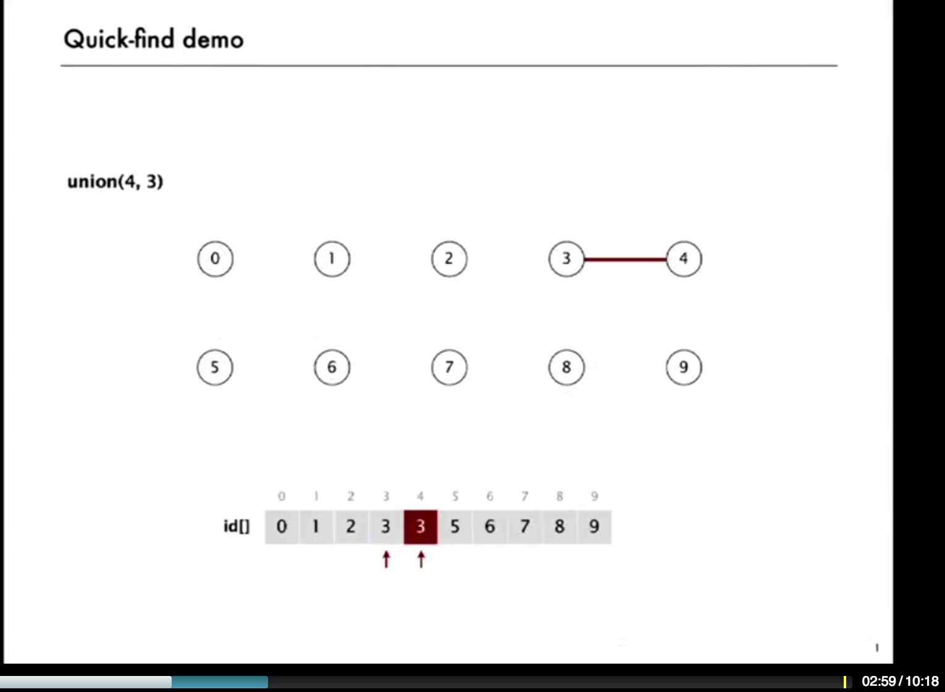  
  
  
I presumed that when we connected 3 to 8, the ids (3,4,8) would all change to 3; but instead they're updated to 8:  
  
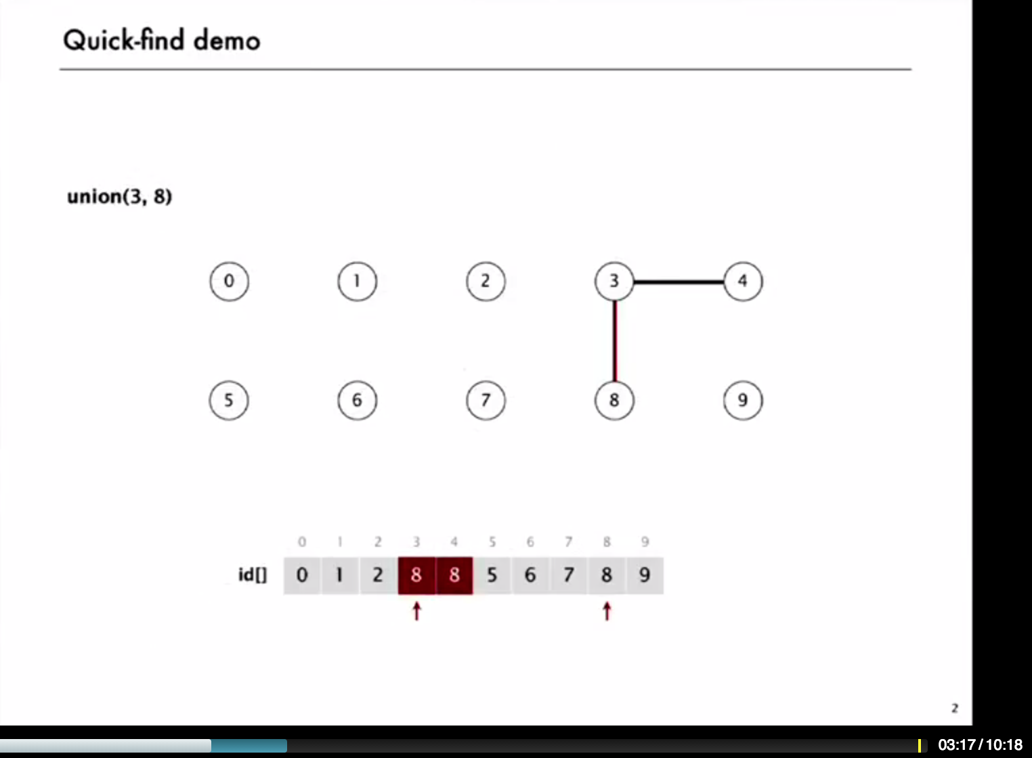  
  
  
Is this id arbitrary, or are there some best practice rules that are being followed here?  
  
Thanks for your help,  
  
Bre

0votes received.

[· flag](https://accounts.coursera.org/i/zendesk/courserahelp?return_to=https://learner.coursera.help/hc/articles/201532585-Code-of-Conduct)

[Ruslan Batdalov](https://class.coursera.org/algs4partI-008/forum/profile?user_id=11604581)· [21 hours ago](https://class.coursera.org/algs4partI-008/forum/thread?thread_id=92" \l "post-714)

This implementation uses a convention that the first one of two nodes being connected is changed to the second one. The opposite convention (change the second one and remain the first one) is also correct, but in exercises we have to use the convention described in the lectures (and in the exercises as well). Other options (assign the minimal number, the maximal number, random choice of two, etc.) will give the same result. In principle you can try to save a few operations by preserving information on the size of each class (and change the one with fewer nodes), but it seems that the overhead for maintaining these structures will be bigger than any gain